***FourOneSixPlayer***

Software and Hardware Specification Sheet

By: Romario Tulloch and Andrew Le

Study: Computer Engineering Technology

**Declaration of Joint Ownership**

We, Romario Tulloch and Andrew Le, confirm that the work we are submitting for assessment is the work created by ourselves, and is from our own words. Any work taken from any other author (programs, figures, techniques, illustrations, or any other material) are properly cited at the point of it’s use. A bibliography is provided at the end of this report, which would contain all sources used in this report.

**Approved Proposal**

1. The name of our project will be the FourOneSix Sound.
2. The summary of the project that we will be putting together is to implement the use of our firebase database to be operating on our hardware. Our hardware is an audio amplifier that will be operating from the raspberry pi 3. The courses that are related to out project are Software project (CENG 319), hardware production tech (CENG 317) and Embedded Systems (CENG 252).
3. Our plan to implement the project is to ensure that the mobile application is working as it should then to ensure that the hardware (audio amplifier) is also operating as it should. The next step will be to figure out how to use the raspberry pi to read from the firebase database automatically. The project will me managed in a systematically way as the critical path will be used as a guide to implement all the steps in putting the project together.

1. In regards to the timeframe of completing the project, it seems very likely as out application needs to undergo a few alterations and the hardware aspect is basically finished. If there are any problems that arises we will be dedicated more time and effort to fix the problem and implement measures to reduce problems in the future.
2. There are few similar products in the market right now such as Spotify and Sound cloud but the difference with our app is that is tailored for the specified hardware.
3. For test cases so far, we can test that App streams the media from the database and use a hard connection from a mobile device to the amplifier to test that the amplifier is still working as it should.
4. In conclusion this project will be a 14-week long project that we will try to incorporate our previous software with the hardware to make a fully functional system that satisfies the need of real world problems.

**Abstract**

The purpose of this project was to create a device(hardware) that would work with a raspberry pi and an app on our phone(software) as an assignment for the computer engineering technology program at Humber College. The hardware device we are creating is a speaker using an audio amplifier that was chosen as our hardware device. The phone app allows for users to send music files to an offset database. This database will store all the account information and also the music files that each account uploads into the database. When command by the phone app, the music files in the database will be downloaded and played through the audio amplifiers/speakers. We feel that this is a great product as many people listen to music regularly and speakers are in very high demand and our product is an easy and user-friendly product. The rest of the report will go through a more thorough analysis of each separate part of the project and will provide more general details about the product.

**Table of Contents**

1. Declaration of Sole Ownership.................................................................................................................1

2. Proposal....................................................................................................................................................2

3. Abstract.....................................................................................................................................................3

4. Table of Contents......................................................................................................................................4

5. Introduction.....................................................................................................................

6. Project Description.....................................................................................................................

6.1. Requirement Specifications............................................................................................

6.2. Hardware.....................................................................................................................

6.3. Software.....................................................................................................................

6.4. Database.....................................................................................................................

6.5. Background.....................................................................................................................

6.6. Problem.....................................................................................................................

6.7. Solution.....................................................................................................................

7. Conclusion.....................................................................................................................

8. Recommendations.....................................................................................................................

9. Bibliography.....................................................................................................................

**Introduction**

The task of testing auto sound systems can be a very tedious task. Plenty of steps that are needed to be take can be monitored and logged to ensure the proper testing of a system especially in the essence to optimize the amplifier levels. This process can even be very expensive in terms of using special hardware to test decibel levels.

We have developed a system that will play specific audio files via the amplifier. The specialized software that we have created will log volume levels manually to a database to keep track of how high the amplifier can go before distortion or clipping occurs.

There are other options that are available to the public that can test amplifier output but does not include the option of logging to a database. We feel that this can be a valuable resource in the audio industry.

**Project Description**

**Requirement Specifications**

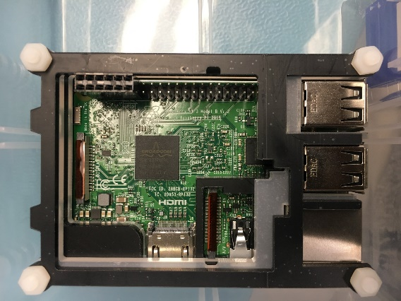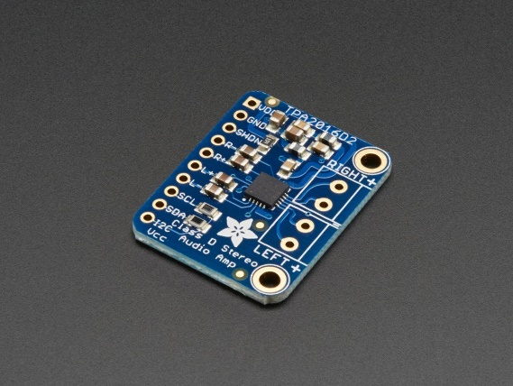**Hardware**

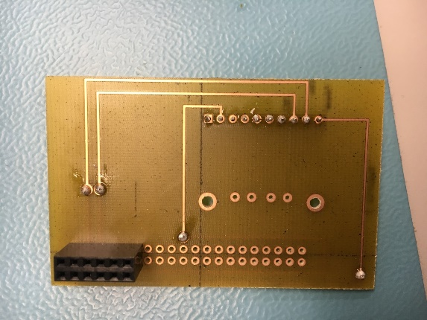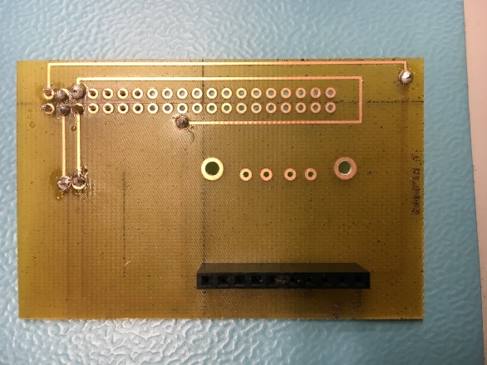Image 1 Image 2

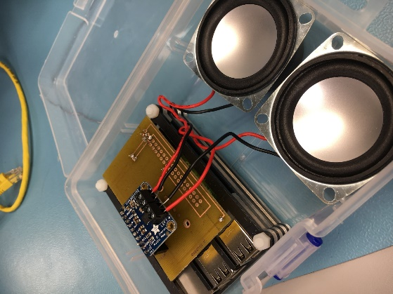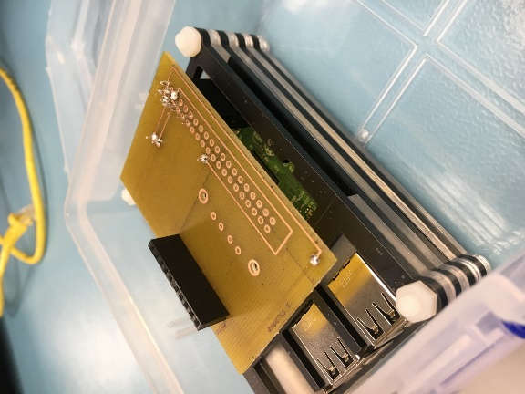 Image 3 Image 4

Image 5 Image 6

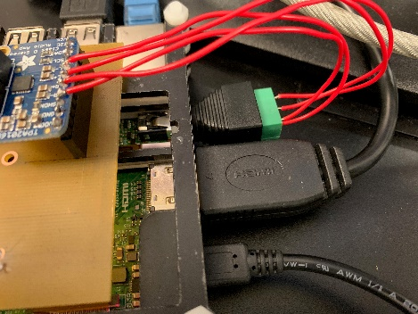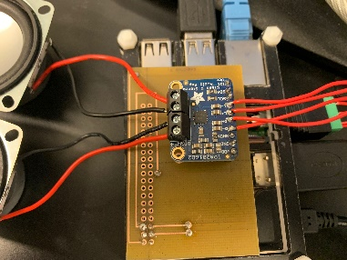

Image 7 Image 8

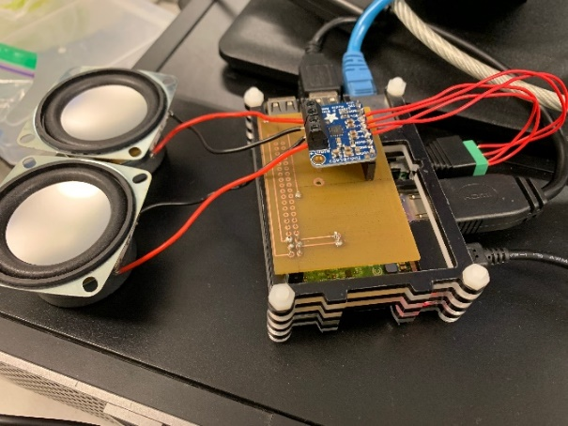

Image 9

**Software**

**Software**

The software being used is an app created on android studio by us. The creation of the app was fairly simple and is very user friendly as it is easy to use and easy to navigate through the application. The main purpose of this android application is to be able to upload and download the music that you want through your phone into the firebase database. This app will allow for those songs to be played once uploaded and the app will also communicate to the hardware through the songs as they are inserted into the database. The app will consist of five major screens and also allows for users to log in and out.

**Loading Screen:**

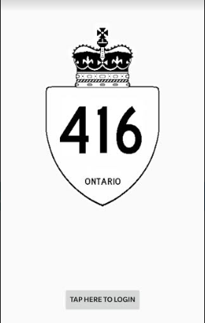

This will be the very first screen that appears when the app is opened. This screen simply shows our logo and a button to enter into the log in page.

**Login Screen:**

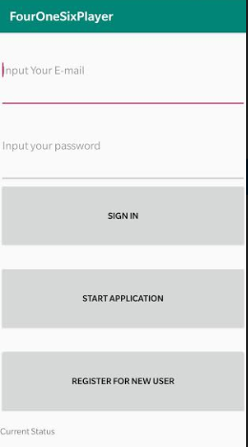

This is the login screen. Here you can log into your account if already made, or you can register for a new account by typing in your email and a password and hitting the register for new user button. There is also the start application button which allows for entry into the app and the home screen will be displayed once that button is clicked.

**Home Screen:**

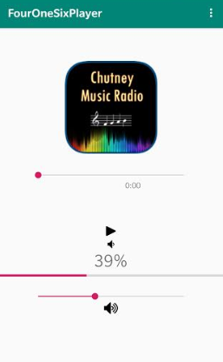

Here we have the home screen. This screen consists of a progress bar that indicates the volume of the speakers and also displays the percentage amount just above the progress bar. There is also a play button that when clicked will start to play the songs. In the top right corner, you can see a menu button, when clicked the menu will open and the option to go to the other screens will be there (as shown below).

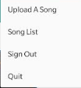

**Upload Screen:**

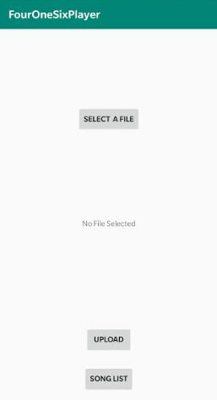

This is the upload screen. Here you can upload the songs that you have chosen into the database. When the select a file button is pressed, you will be asked permission to allow for the app to access files that you have in your phone. Once permission is granted a screen where your files will appear and this is where you select the song. Once selected the file name will show up in the middle of the screen, once ready to upload, the upload button sends the song to the database and is ready to be downloaded. The song list button will send the users to the song list screen.

**Songs List Screen:**

**(work in progress, no screenshot available)**

This screen will allow for users to see the songs uploaded into the database and when the song is clicked, the song will then be downloaded and ready to be played.

**Database**

For the database connection, we are storing or files in the firebase storage, and using the database for the song names and the download link.

Database:

*PUT DATABASE SCREENSHOT HERE*

As you can see in the screenshot, the database will be storing the song names and the download link for easy access to retrieve each song in the app.

Storage:

*PUT STORAGE SCREENSHOT HERE*

As you can see in the screenshot above, the storage will be used to store the audio files so that the songs can be played within the application.

**Background**

**Problem**

**Solution**

**Conclusion**

**Recommendations**

**Bibliography**